:росток:Beet Seed — відпрацюй навички на базовому рівні.

1. Протестуй роботу сайту “[Київська міська лікарня ветеринарної медицини](https://www.kmlvm.com.ua/)” на мобільному пристрої.

2. Заведи 5 відповідних баг репортів у файл Google Docs. Додай посилання на нього в LMS.

1. Copyright date information is not updated at the bottom of the webpage.

**Description**:

When checking copyright information at the bottom of the webpage, you can see that the date is not updated and showing 2023.

**Steps to reproduce:**

1. Open website <https://kmlvm.kyivcity.gov.ua/>
2. Scroll down to the bottom of the website and check copyright information.

**Actual result:** The copyright information contains the old date.

**Expected result:** The copyright information is up-to-date.

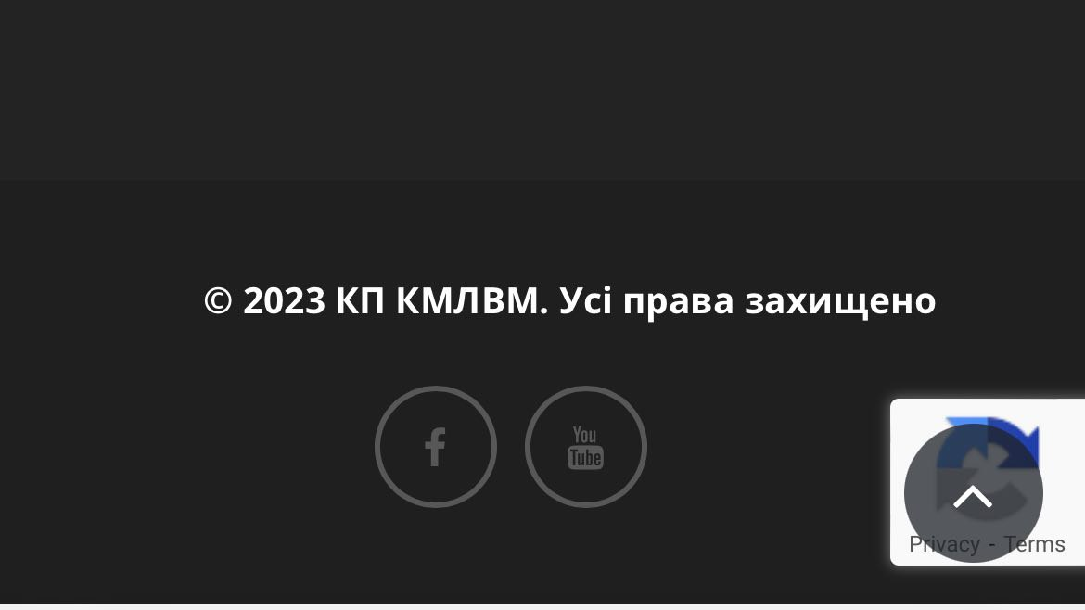

**Tested on:** iPhone 12, iOS 17.3.1, Safari.

2. The Facebook link button does not open the Facebook page of the company.

**Description**:

When tapping on Facebook link button in the footer of the website, it does not redirect you to the Facebook page of the company.

**Steps to reproduce:**

1. Open website <https://kmlvm.kyivcity.gov.ua/>
2. Scroll down to the footer of the website.
3. Find and tap on the Facebook link button.

**Actual result:** The link redirects to Facebook but does not show the company’s page. Instead it shows the link error.

**Expected result:** The link redirect to the working Facebook company page.

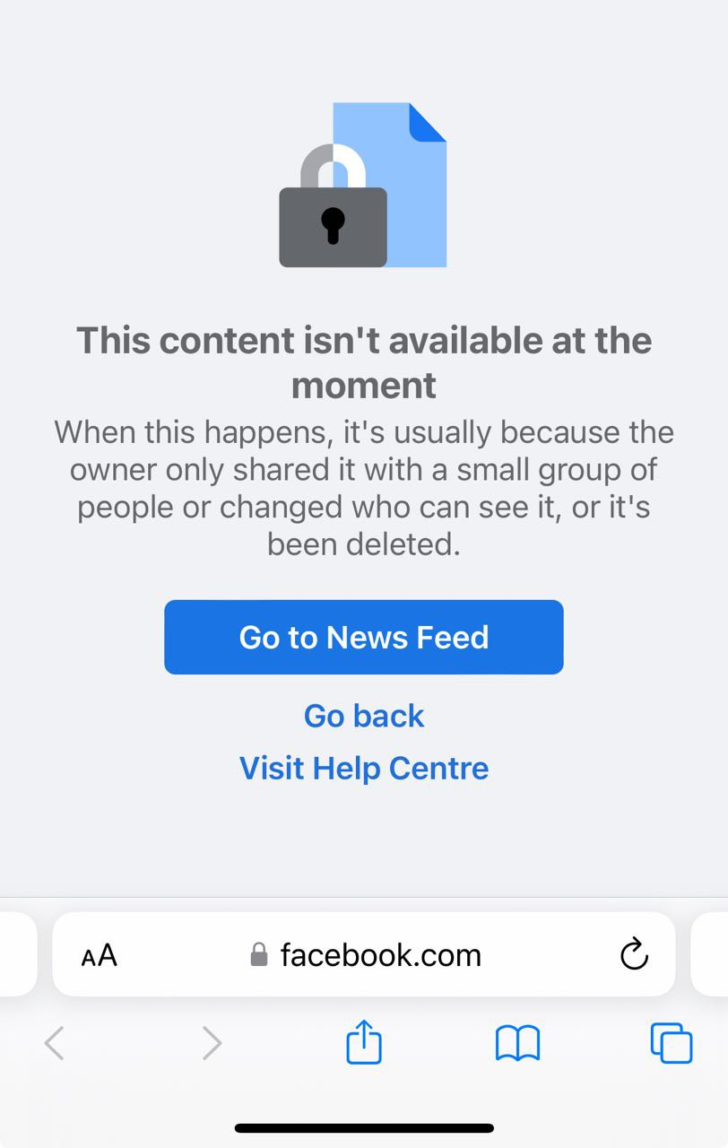

**Tested on:** iPhone 12, iOS 17.3.1, Safari.

3. The Youtube logo on the link button has an old style.

**Description**:

When looking at the Youtube link button in the footer of the website, it has an old style.

**Steps to reproduce:**

1. Open website <https://kmlvm.kyivcity.gov.ua/>
2. Scroll down to the footer of the website.
3. Look at the Youtube link button.

**Actual result:** The Youtube logo on the link button has an old style.

**Expected result:** The Youtube logo on the link button should be up-to-date.



**Tested on:** iPhone 12, iOS 17.3.1, Safari.

4.The “Send us message” form does not send messages.

**Description**:

When trying to send a message through “Send us message” form on the Contacts page of the website, the message can not be sent and the error message appears.

**Steps to reproduce:**

1. Open the website Contacts page <https://kmlvm.kyivcity.gov.ua/contact-us/>.
2. Scroll to the “Send us message” form.
3. Fill out the form with valid information and tap the “Send” button.

**Actual result:** The “Send us message” form does not send messages and the error message appears.

**Expected result:** The message in the form is sent and a message with a successful result appears.

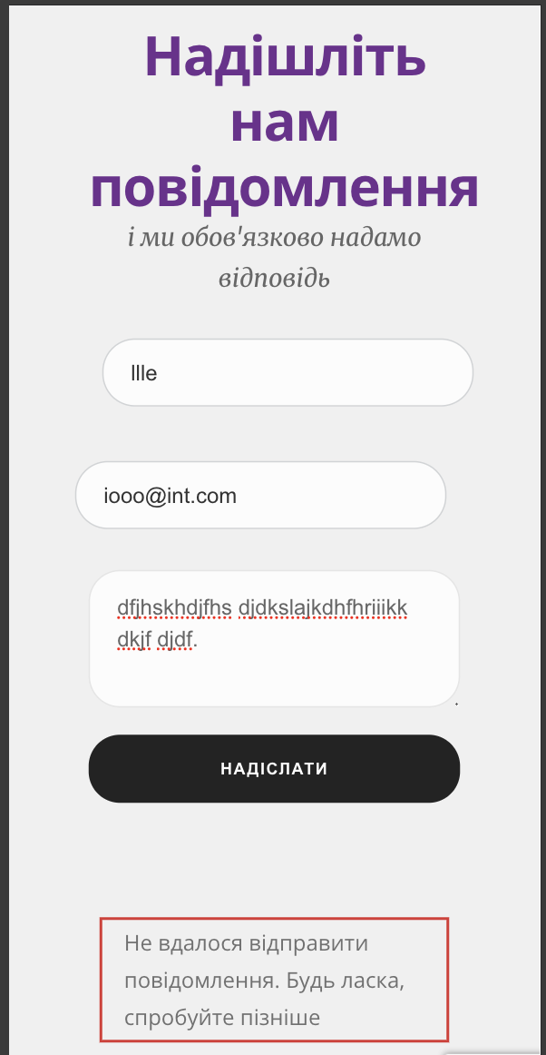

**Tested on:** iPhone 12, iOS 17.3.1, Safari.

5. Words in headings on the “Animal registration” page are moved to the next line .

**Description**:

When looking on the “Animal registration” page of the website, words in headings in the page body do not have enough space and are moved to the next line, breaking words into 2 pieces.

**Steps to reproduce:**

1. Open the website “Animal registration” page <https://kmlvm.kyivcity.gov.ua/reyestratsiya-tvaryn/>.
2. Scroll to check headings in the body of webpage.

**Actual result:** Words in headings in the page body do not have enough space and are moved to the next line.

**Expected result:** Words in headings should have enough space and should not be moved to a different line, breaking the word into 2 pieces.

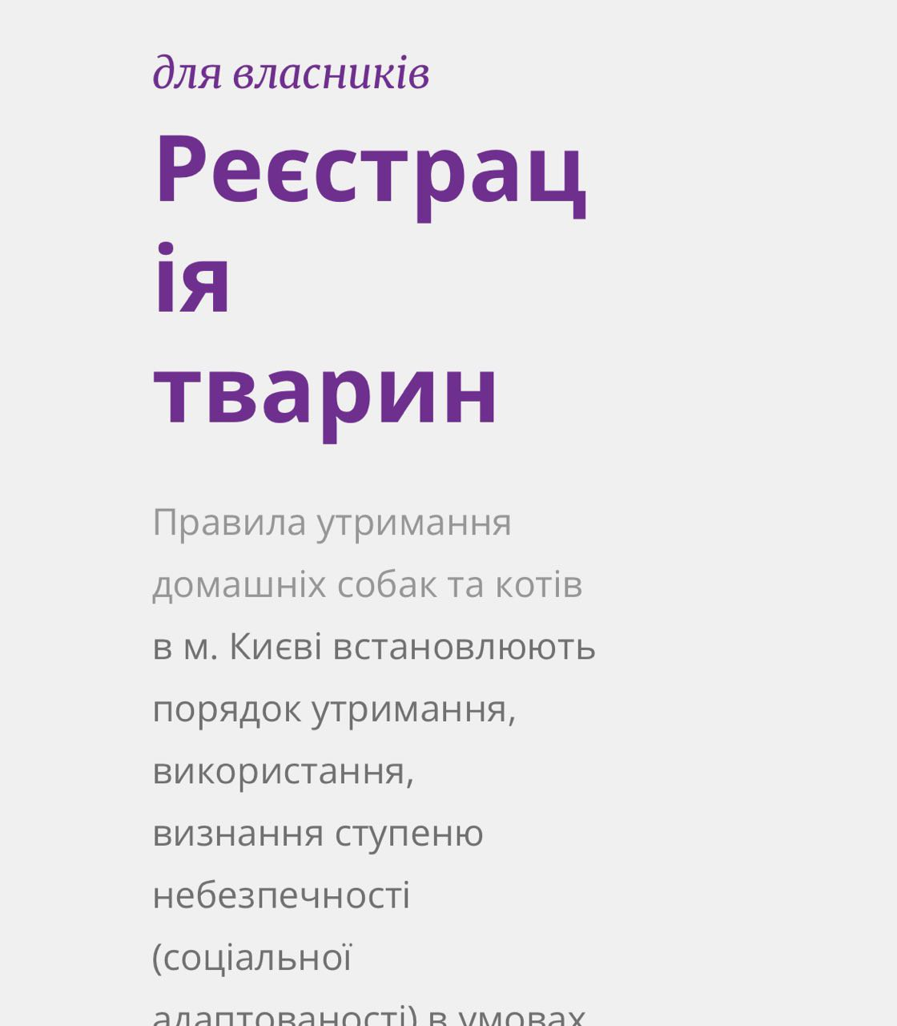

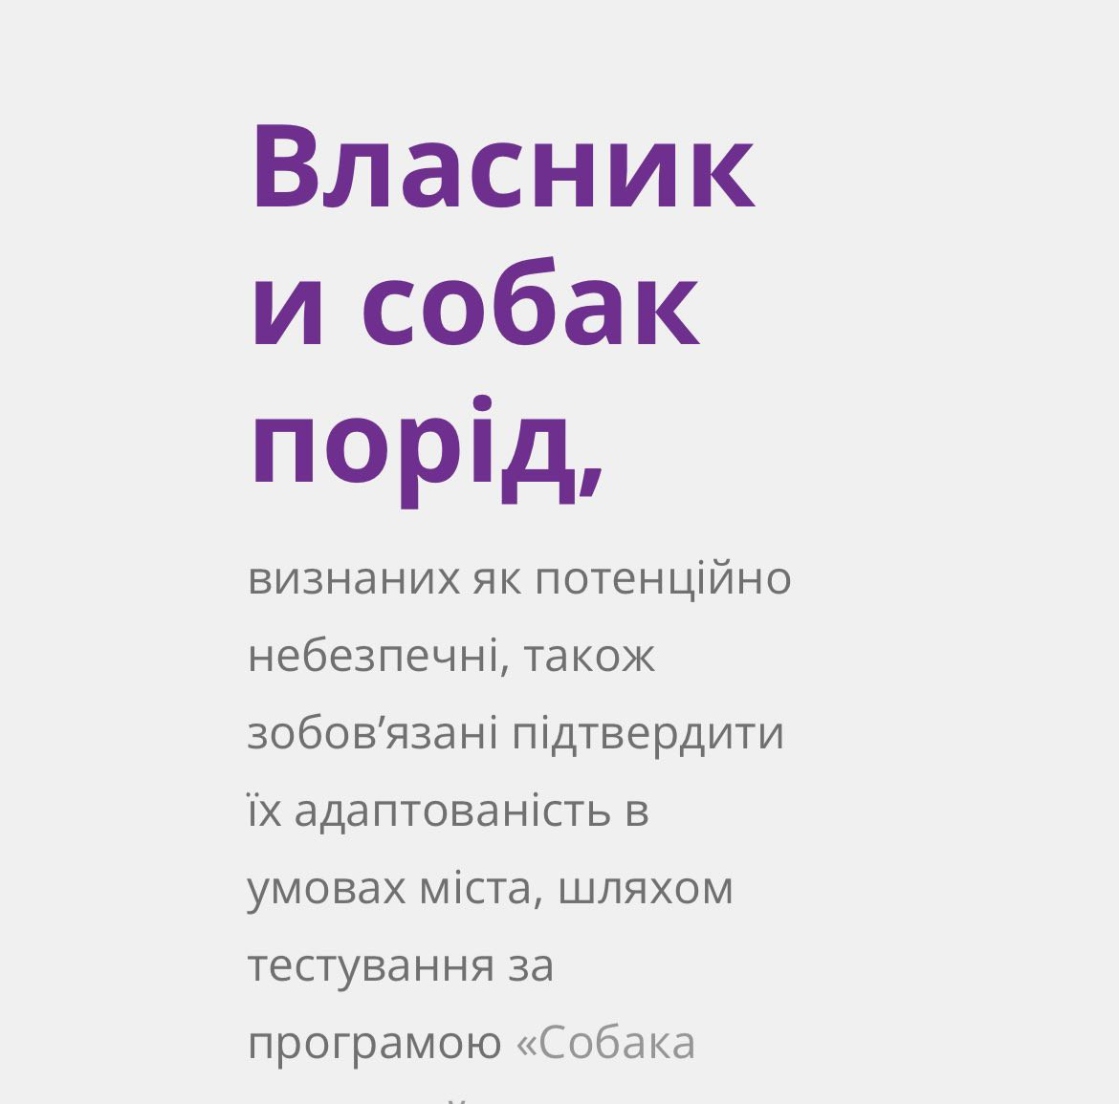

**Tested on:** iPhone 12, iOS 17.3.1, Safari.